

**User Manual**

**EFRConnect Door Lock Mobile Application**

|  |  |
| --- | --- |
| **Version**  **Status**  **Date** | 0.1  Draft  24-August-2020 |

**Confidentiality Notice**

Copyright (c) 2020 eInfochips. - All rights reserved

This document is authored by eInfochips and is eInfochips intellectual property, including the copyrights in all countries in the world. This document is provided under a license to use only with all other rights, including ownership rights, being retained by eInfochips. This file may not be distributed, copied, or reproduced in any manner, electronic or otherwise, without the express written consent of eInfochips.

Contents

1 Document Details 6

1.1 Document History 6

1.2 Definition, Acronyms and Abbreviations 7

1.3 References 8

2 introduction 9

2.1 About EFR32 Door Lock System 9

2.1.1 Key Features 10

2.2 Kit Contents 10

3 System Requirements 11

3.1 Typical Setup Requirements 11

3.2 Special Configuration and environment 11

3.3 Support Documentation list 11

3.4 Considerations: 11

4 Getting Started 12

4.1 Installation 12

4.2 Splash Screen 13

4.3 Granting permissions. 14

4.4 Home Page 15

4.5 Device Scanning and Discovery Screen 16

4.6 Door Lock Parameter Screen 17

4.7 Door Lock Option Menus 18

4.8 3x4 Matrix Keypad Screen 19

4.9 OTA Provisioning Service Screen 20

4.10 OTA Processing Screen 21

4.11 Instructions/Conventions/Errors 22

4.11.1 Navigation for Door Lock/Unlock 22

4.11.2 Navigation for OTA 23

5 Known Issues 24

6 Limitations and constraints 25

7 Warranty And Support 26

8 Upgrade and Add On Modules 27

9 Technical Support 28

10 Appendix 29

**FIGURES**

Figure 1: Top Level EFR32 Door Lock System Diagram 9

Figure 2: Unknown source installation setting 12

Figure 3: Splash Screen 13

Figure 4: Home Screen 15

Figure 5: Scanning / Discovery of nearby devices 16

Figure 7: Door Locked /Unlocked Status 17

Figure 9: Door Lock Option Menus 18

Figure 10: 3x4 Matrix Keypad Screen 19

Figure 11: OTA Provisioning Service 20

Figure 12: OTA Selection Dialog / Update File Selection 21

Figure 14: Lock/Unlock Operation Navigation 22

Figure 15: OTA Provisioning Navigation 23

**TABLES**

Table 1: Document History 6

Table 2: Definition, Acronyms and Abbreviations 7

Table 3: References 8

# Document Details

## Document History

|  |  |  |  |  |  |  |
| --- | --- | --- | --- | --- | --- | --- |
| **Version** | **Author** | | **Reviewer** | | **Approver** | |
| **Name** | **Date**  **(DD-MM-YYYY)** | **Name** | **Date**  **(DD-MMM-YYYY)** | **Name** | **Date**  **(DD-MM-YYYY)** |
| Draft 0.1 | Vipul Kole | 21-08-2020 | Shachi Mahajan |  |  |  |
|  |  |  |  |  |  |  |

| **Version** | **Description of Change** |
| --- | --- |
| Draft 0.1 | Created initial draft version |
|  |  |

Table 1: Document History

## Definition, Acronyms and Abbreviations

|  |  |
| --- | --- |
| Definition/Acronym/Abbreviation | Description |
| User | User of EFRConnect Mobile application |
| OTA | Over the Air |
| BLE | Bluetooth Low Energy |
|  |  |

Table 2: Definition, Acronyms and Abbreviations

## References

|  |  |  |  |
| --- | --- | --- | --- |
| No. | Document | Version | Remarks |
| 1 | ei_SW_TMP_SystemRequirementSpecification_SiLabs_Door_Lock_Draft_04 | 0.4 | SRS |
| 2 | ei_SW_TMP_DesignSpecification_SiLabs_Door_Lock_Draft_04 | 0.4 | SDD |

Table 3: References

# introduction

## About EFR32 Door Lock System

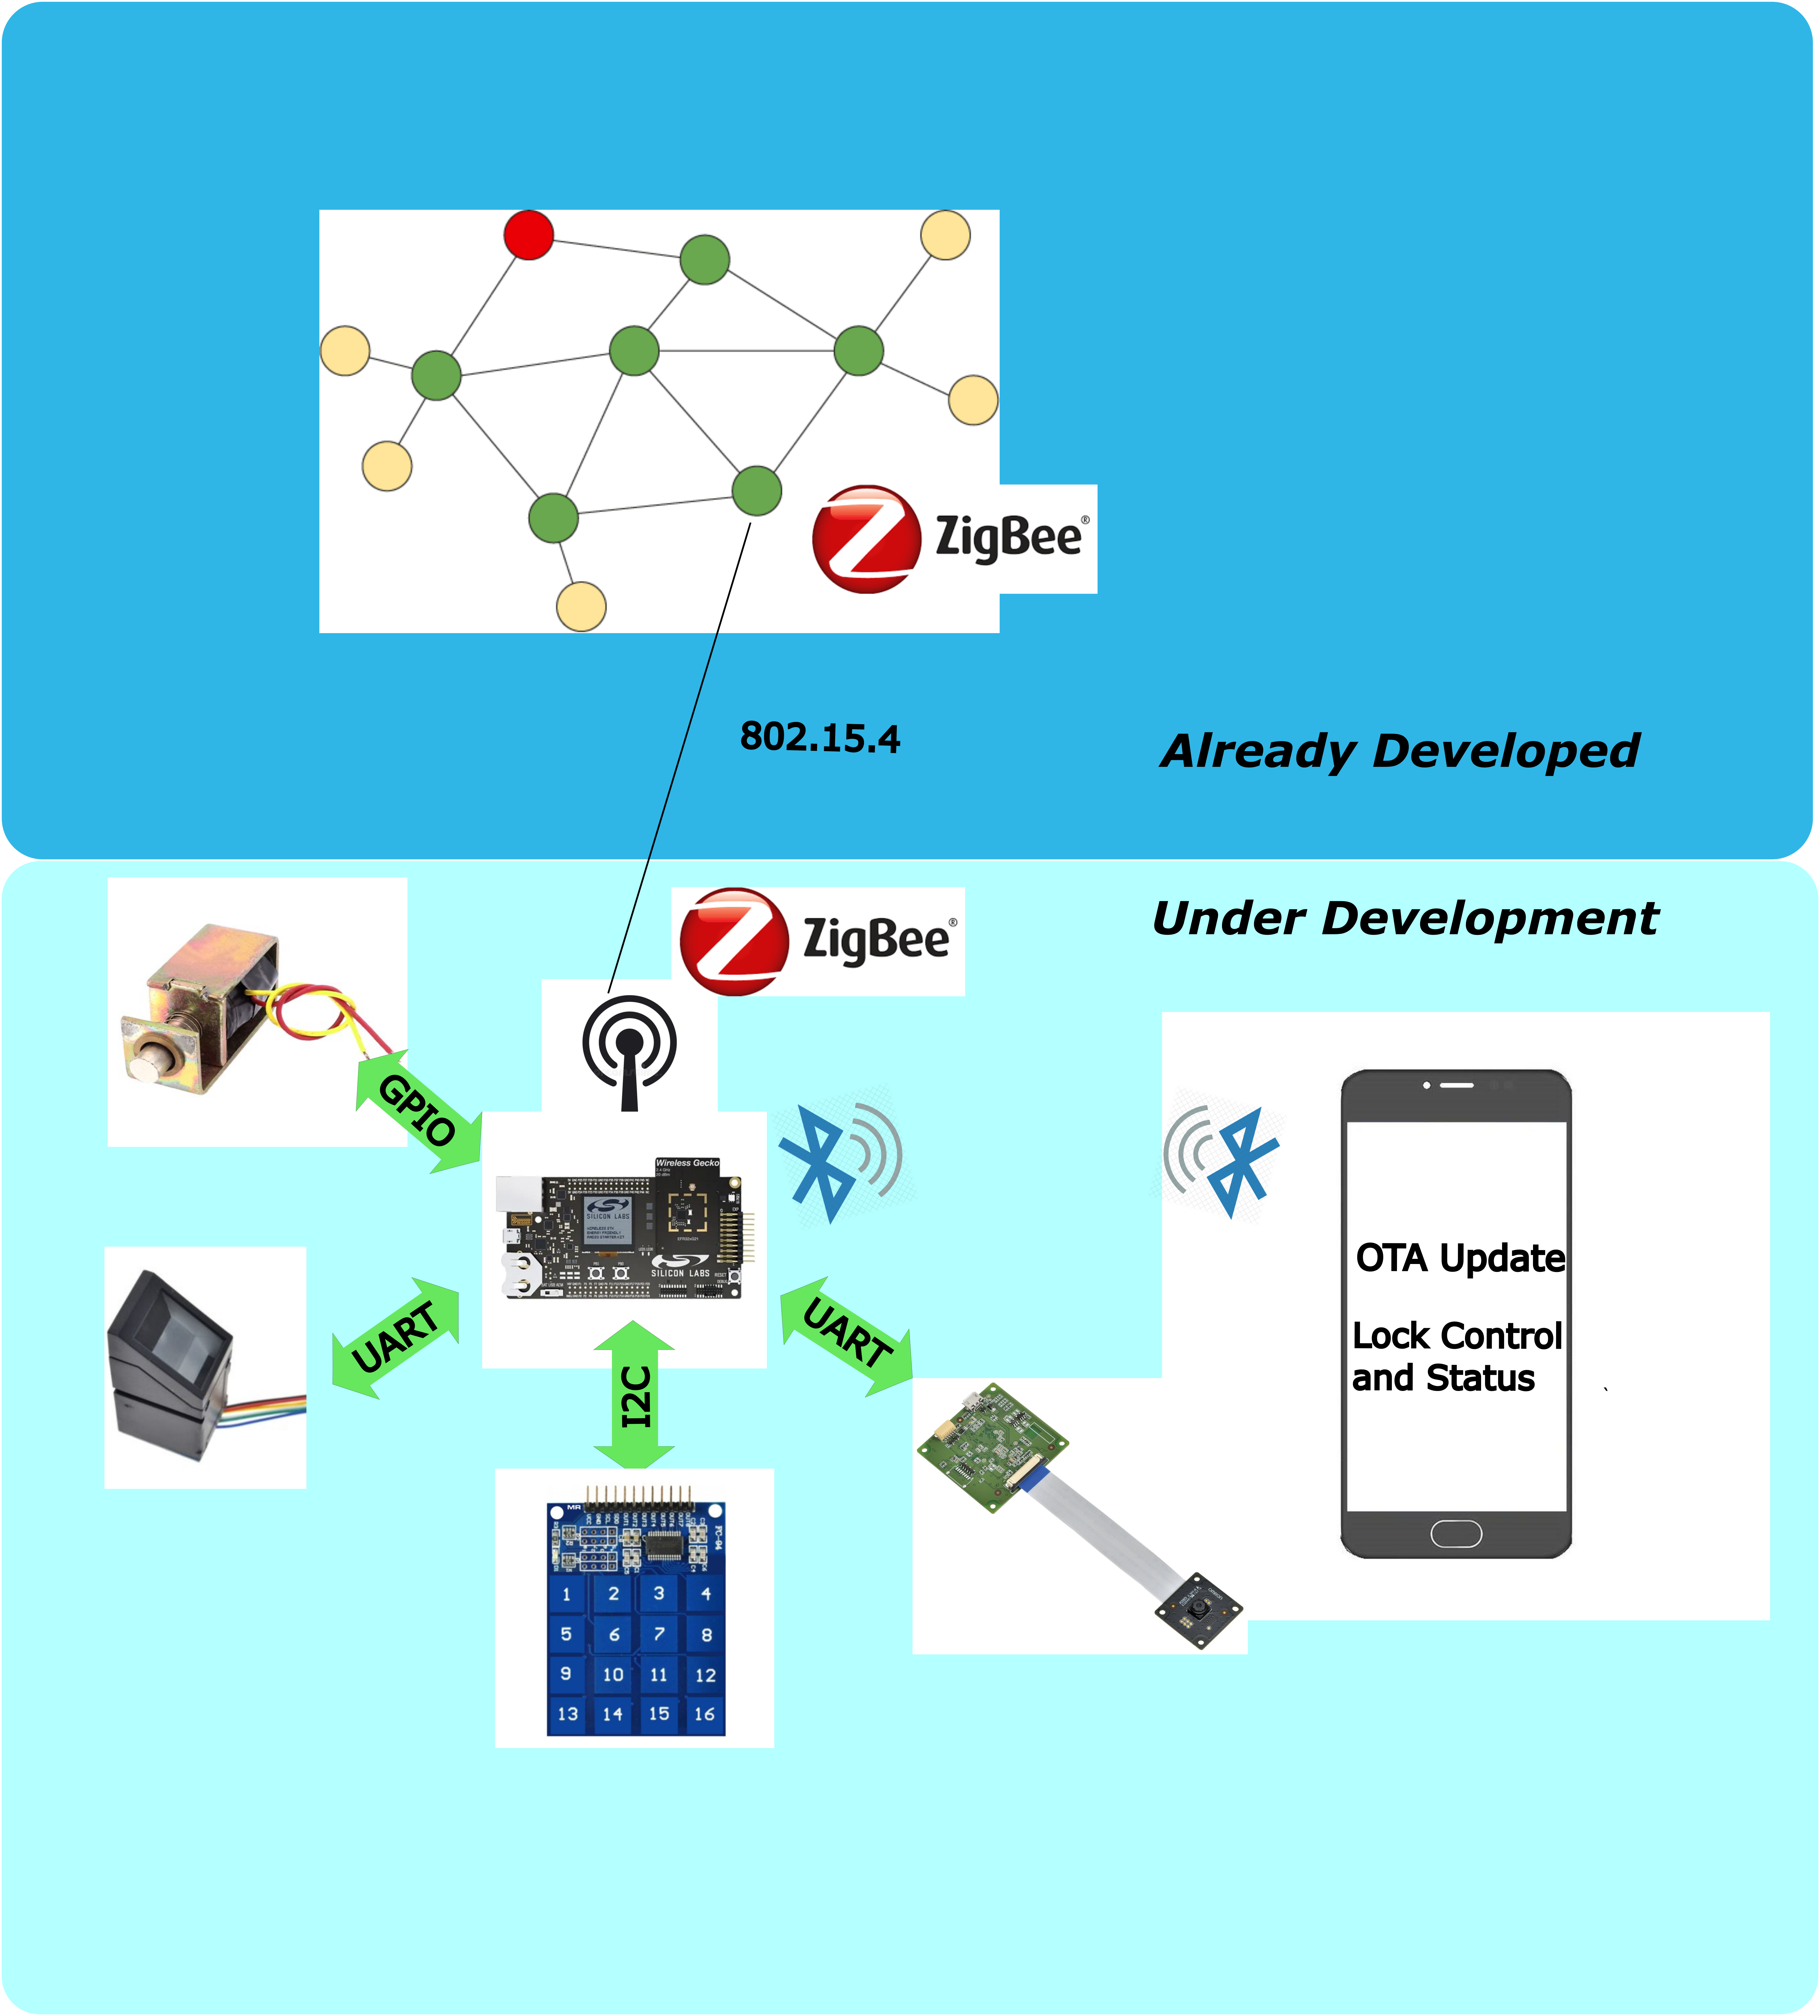

Figure 1: Top Level EFR32 Door Lock System Diagram

Door lock application based on EFR32MG21 application layer framework is used to achieve the smart locking of home, building and commercial space. EFR32MG21 supports dynamic multiprotocol which allows ZigBee and BLE to work concurrently. Where ZigBee will be used as backend networking and BLE will be used for mobile connectivity. This reference platform provides locking and unlocking of door using authentication. It has 1 step and 2-step authentication to open/close the door.

1-step authentication is using:

* Fingerprint sensor authentication
* Keypad input
* Face recognition

2-step authentication is using:

* Keypad input and Face recognition
* Keypad input and Fingerprint match

Mobile application is used in the application to control or monitor the status of the door lock. Also, OTA update functionality is supported to download the firmware updates to the EFR board.

### Key Features

* 1-stage & 2-stage authentication for door lock
* Door lock & Unlock through mobile app
* Door lock state status & notification on mobile app
* OTA provisioning

## Kit Contents

NA.

# System Requirements

## Typical Setup Requirements

* User’s permission like Bluetooth and Location services is required.

## Special Configuration and environment

* User mobile should be nearer to the EFR32 door lock device (around 20ft radius)

## Support Documentation list

NA

## Considerations:

* Android device must have android version 7 or above.
* Android device time must be set to current time.
* Android device should have support for Bluetooth version 4+ (Bluetooth LE)
* GPS must be enabled

# Getting Started

## Installation

* Copy the **EFRConnect Door Lock-v x.x.x.apk** file into your Android Mobile Phone.
* Install the application by running apk file.
* If the installation permission needed, then android will automatically navigate to allowing the “UNKNOWN SOURCE INSTALLTION” setting

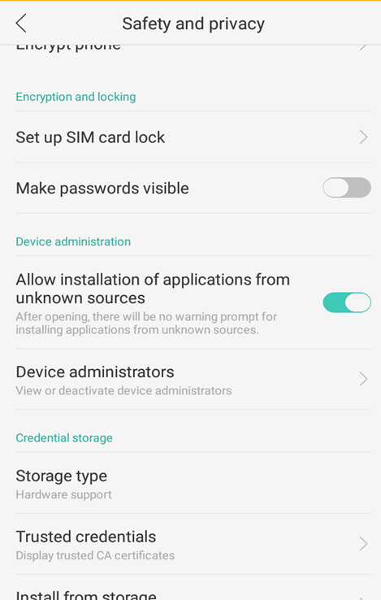

Figure 2: Unknown source installation setting

* + Allow the system to install the application
  + It may ask for google play protect security check. Click on “Install anyway”

## Splash Screen

* Launch EFRConnect Door Lock Application from Mobile Device.
* User will see the splash screen of silicon labs logo. Once loading completed user will see “Home screen.

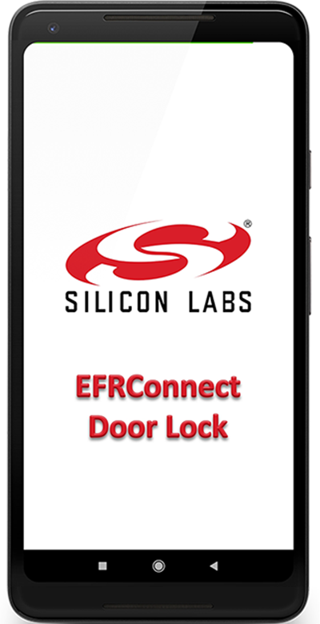

Figure 3: Splash Screen

## Granting permissions.

* Allow all the permission asked by the application.

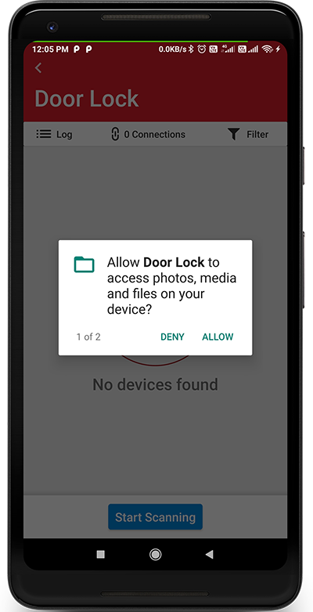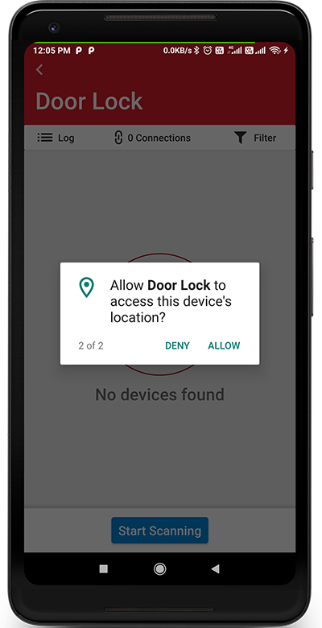

Figure 2: Permission Screen

## Home Page

Click on scan button to display the list of available Bluetooth devices

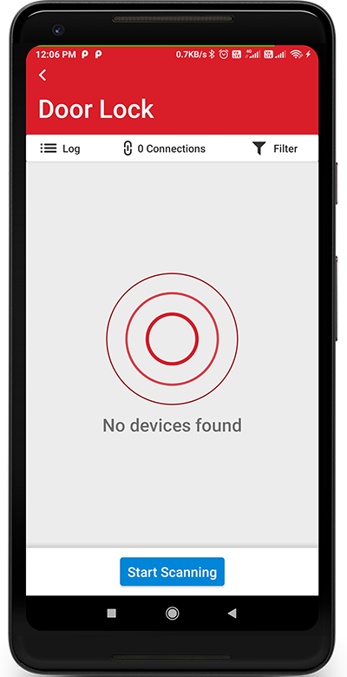

Figure 4: Home Screen

## Device Scanning and Discovery Screen

After clicked on scan button it will display scanning animation and shows the nearby Bluetooth devices. Select the EFR device (DMP4428)

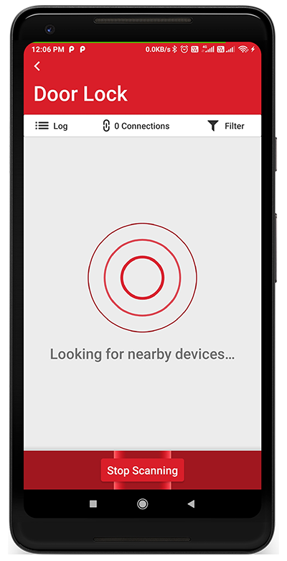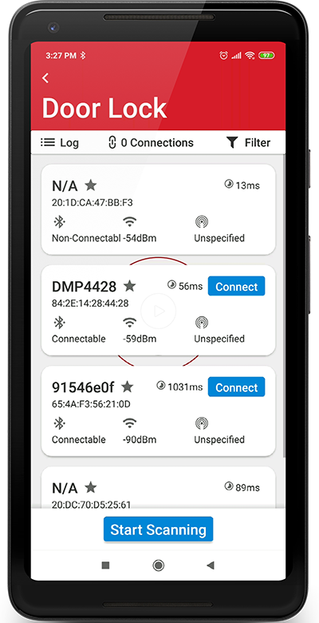

Figure 5: Scanning / Discovery of nearby devices

## Door Lock Parameter Screen

It will show the EFR32 connection status, door status, device name and actions performed by the user.

Also, it has a menu option button and refresh button to get the latest device state. (syncing with device)

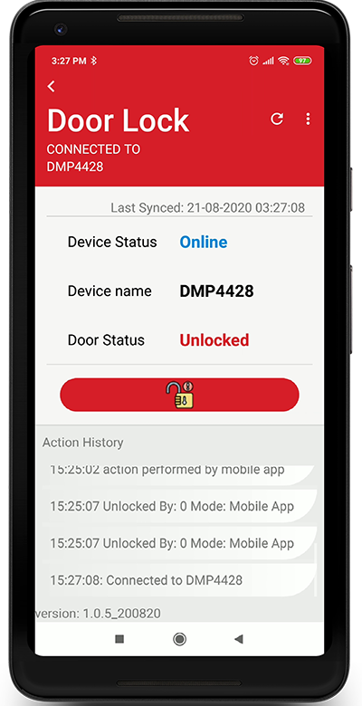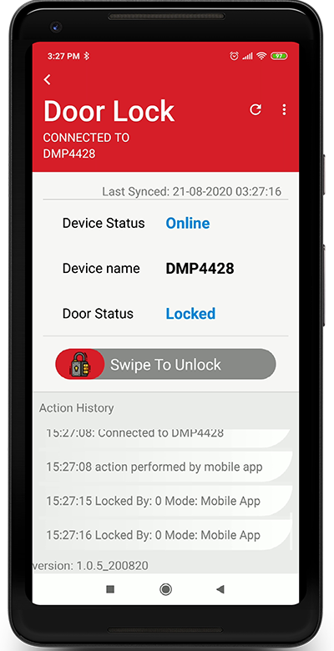

Figure 7: Door Locked /Unlocked Status

## Door Lock Option Menus

Currently it has two option menus as OTA and Exit. OTA will used for updating the firmware application. Exit will navigate to home screen.

By pressing the 3 dots icon at top right corner the option menu will visible.

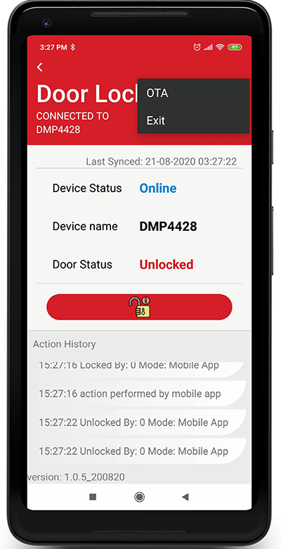

Figure 9: Door Lock Option Menus

## 3x4 Matrix Keypad Screen

When lock/unlock operation is going to happen from mobile app, then mobile app user needs to provide a secret key to perform the operation. This screen will pop up when lock or unlock event is triggered.

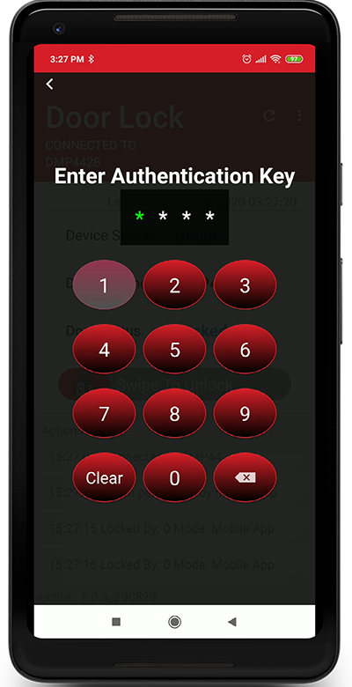

Figure 10: 3x4 Matrix Keypad Screen

## OTA Provisioning Service Screen

After selecting the OTA option from the menu, the below screen will appear and the option menus are changed as respect to the service.

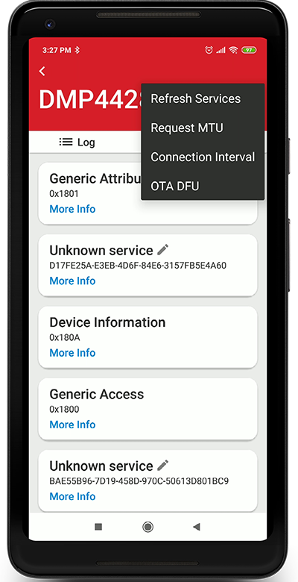

Figure 11: OTA Provisioning Service

## OTA Processing Screen

After selecting the OTA, popup dialog will appear to provide an application file for firmware as shown in picture. Then user need to provide a firmware application file.

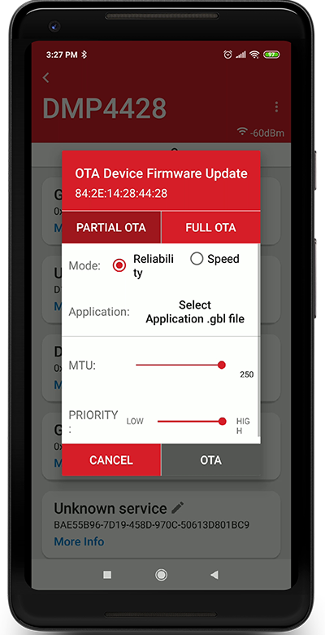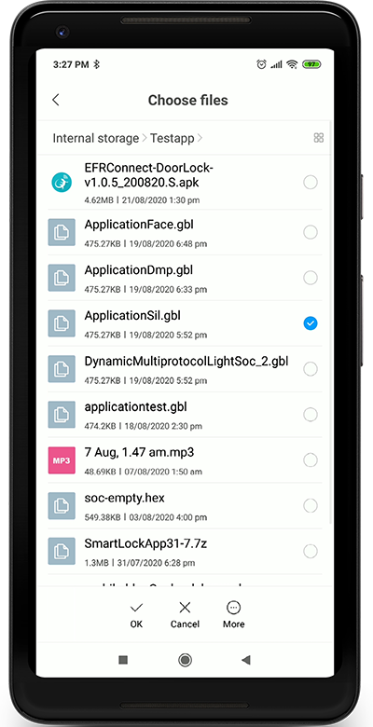

Figure 12: OTA Selection Dialog / Update File Selection

## Instructions/Conventions/Errors

### Navigation for Door Lock/Unlock

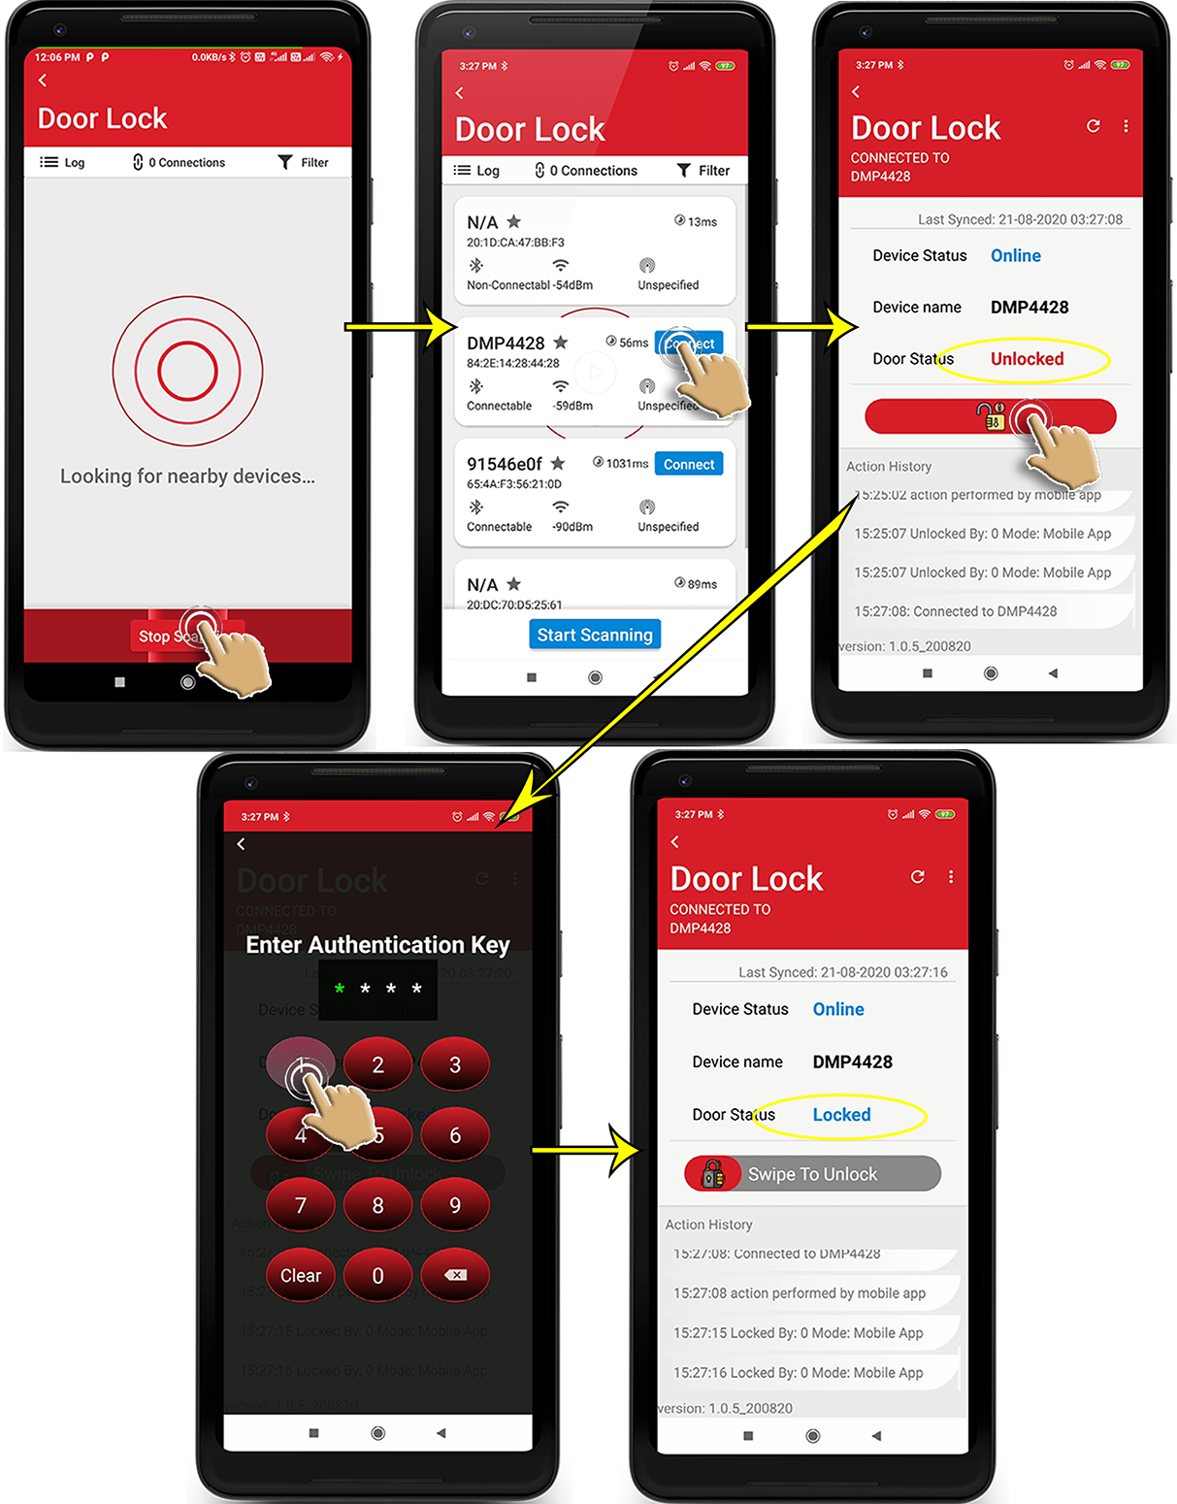

Figure 14: Lock/Unlock Operation Navigation

### Navigation for OTA

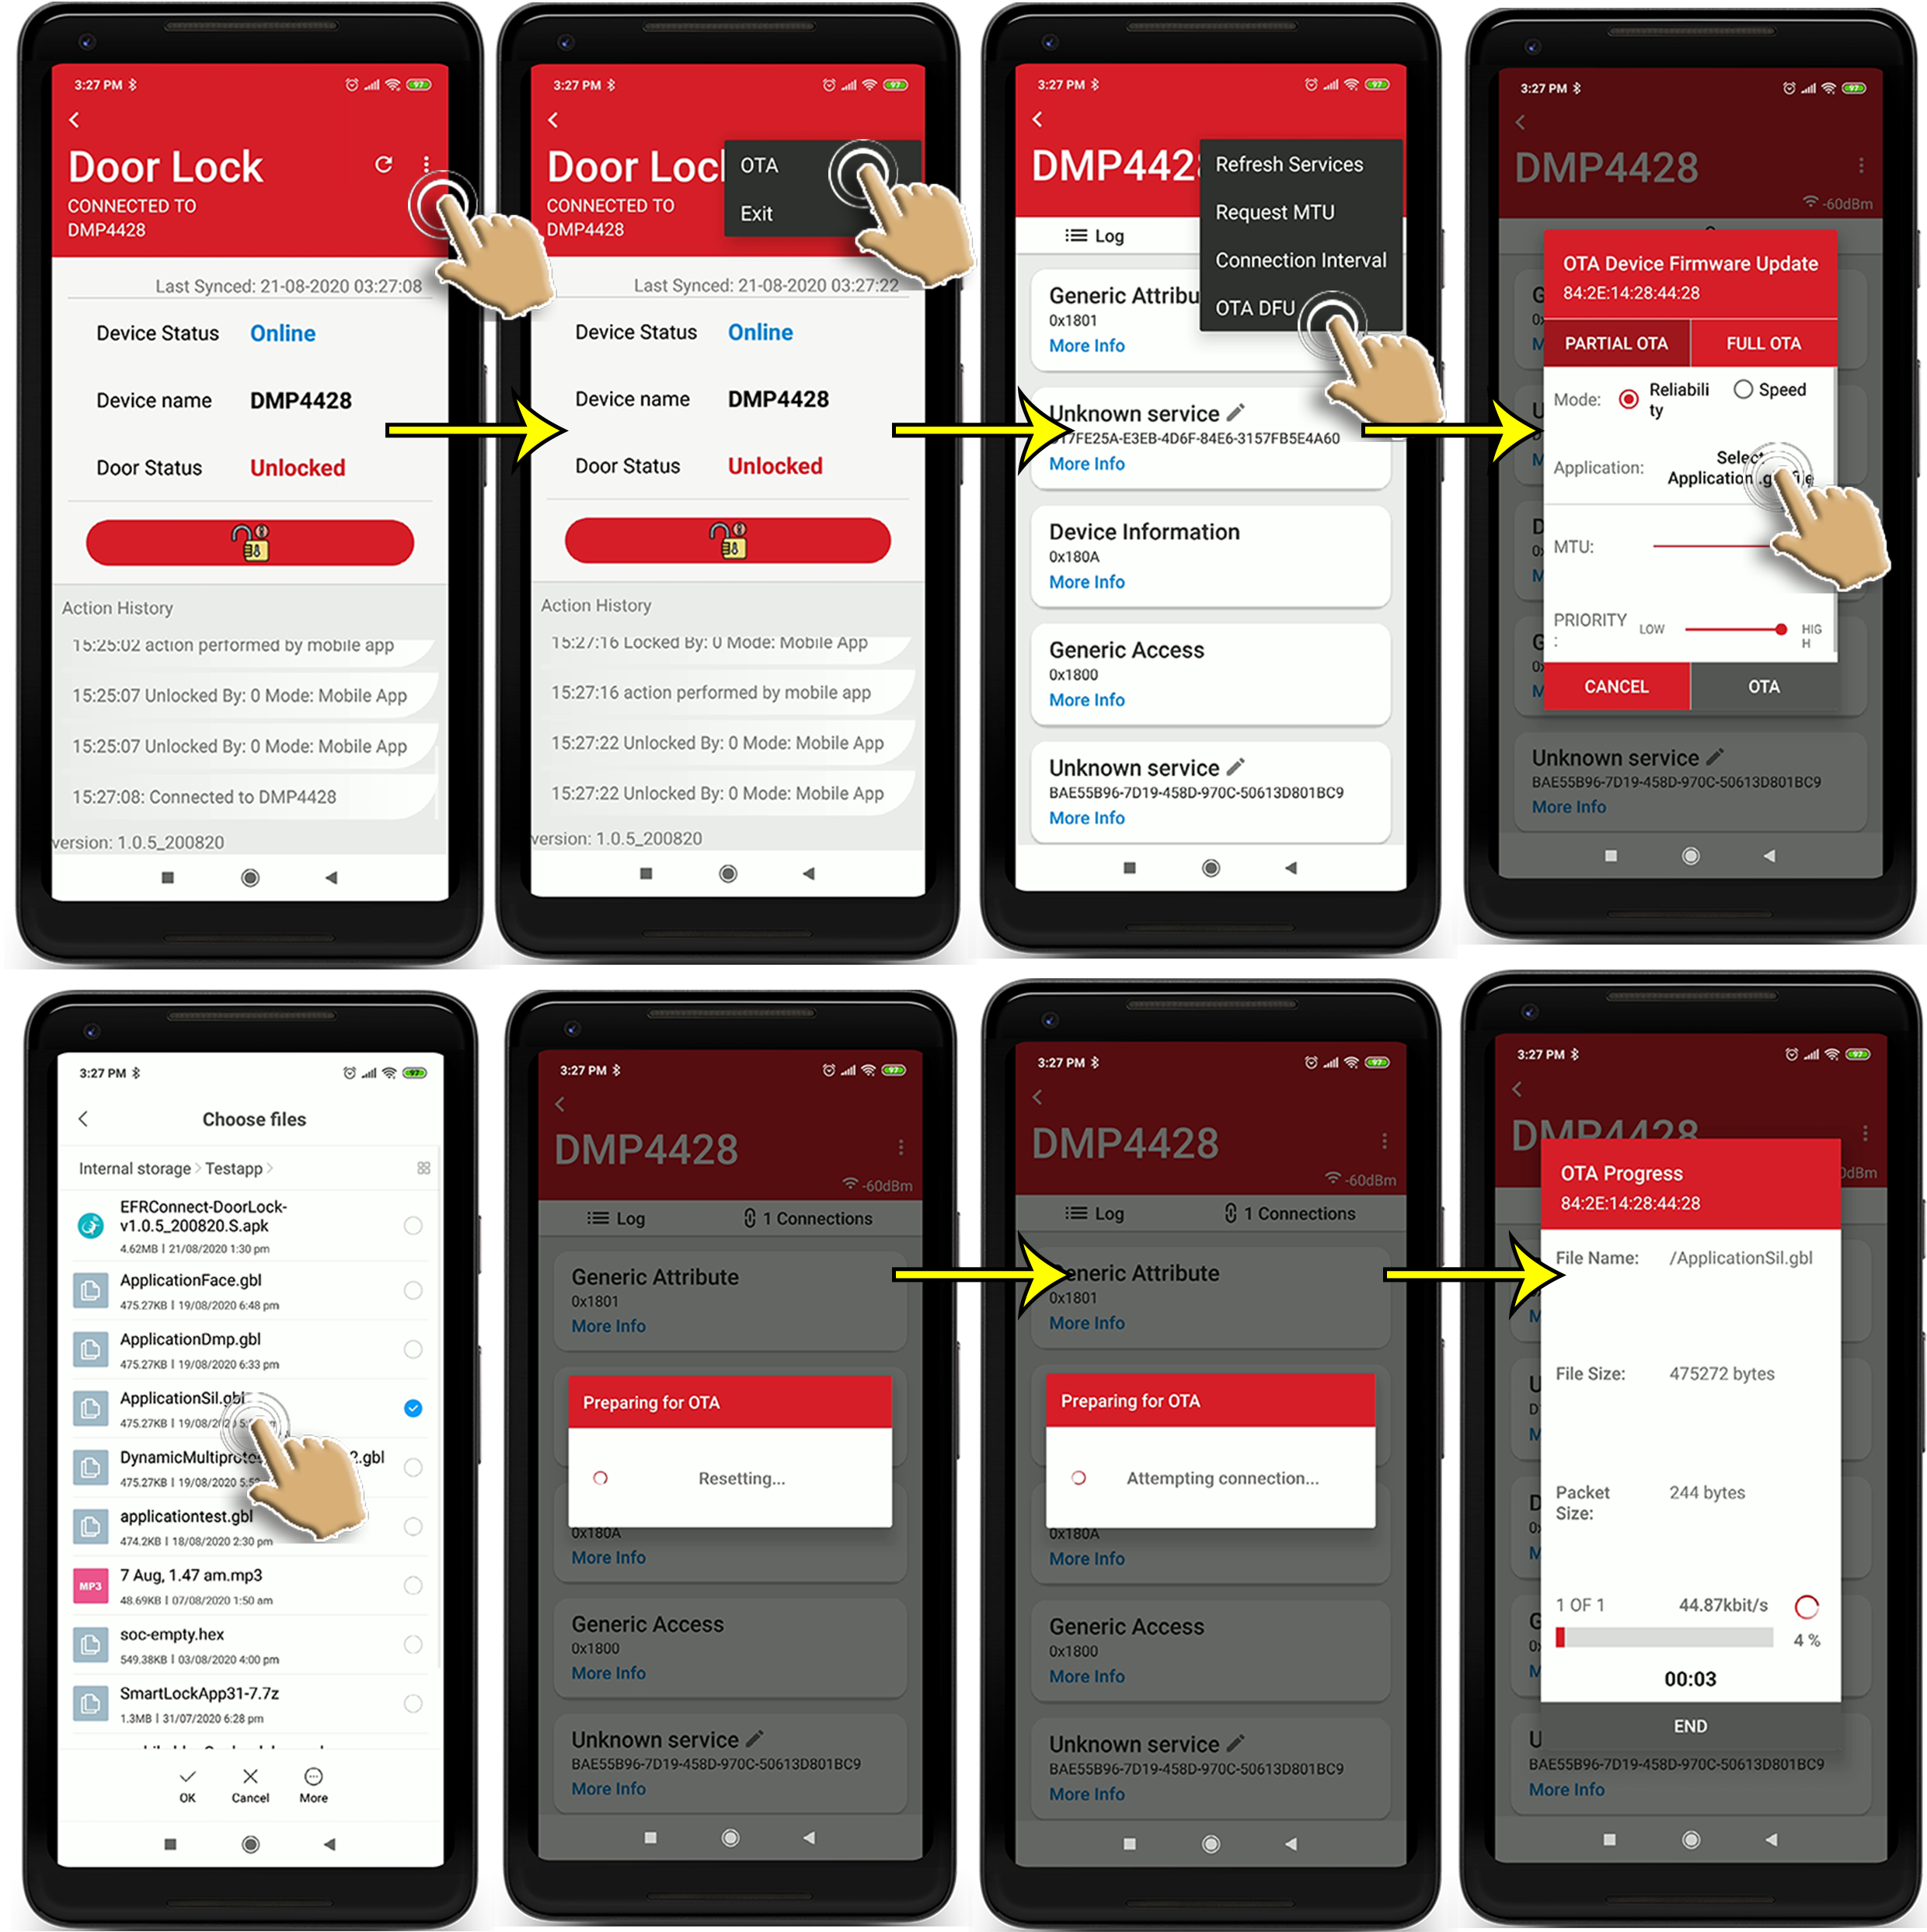

Figure 15: OTA Provisioning Navigation

# Known Issues

# Limitations and constraints

# Warranty And Support

NA.

# Upgrade and Add On Modules

NA.

# Technical Support

NA

# Appendix